Case Study Report

# Data Analytics with Power BI

**“360-DEGREE BUSINESS ANALYSIS OF ONLINE DELIVERY APPS”**

**“GOVERNMENT ARTS COLLEGE FOR WOMEN”**



3



**Tech Saksham**

|  |  |
| --- | --- |
| **NM ID** | **NAME** |
| 697CAF71255C84E9E6340298EFEA37AF | Bhuvaneswar.S |

**Trainer Name**: R UMAMAHESWARI

**Master Trainer**: R UMAMAHESWARI

# ABSTRACT

In the digital world, Online food ordering system is mainly designed primarily function for use in the food delivery industry. This system will allow hotels and restaurants to increase online food ordering such type of business. The customers can be selected food menu items just few minutes. In the modern food industries allows to quickly and easily delivery on customer place. Restaurant employees then use these orders through an easy to delivery on customer place easy find out navigate graphical interface for efficient processing.



## INDEX



|  |  |  |
| --- | --- | --- |
| **Sr. No.** | **Table of Contents** | **Page No.** |
| 1 | Chapter 1: Introduction | 4 |
| 2 | Chapter 2: Services and Tools Required | 6 |
| 3 | Chapter 3: Project Architecture | 7 |
| 4 | Chapter 4: Modeling and Result | 9 |
| 5 | Conclusion | 15 |
| 6 | Future Scope | 16 |
| 7 | References | 17 |
| 8 | Links | 18 |



### CHAPTER 1 INTRODUCTION

**1.1 Problem Statement:**

Different food delivery applications often provide different offers or discounts. Users are also not satisfied with their delivery time and random cancellations.

The current food delivery applications provide different discounts on the same item but in different platform. It is also seen that delivery time of an item is not same in all the applications. Adding all the discounts and estimated delivery time of different food joints under a single interface will be economical and less time consuming**.**

**1.2 Proposed Solution:**

The proposed solution is to develop a Power-BI dashboard that can analyze and visualize Business Analysis of food delivery App. It’s time to create solutions for the problem. To understand their situation, I have to step into their shoes. Here are the ideas that I have thought of Bringing discounts and offers of different applications under a single interface. Comparing the delivery time of different apps together. Users will get an idea of the timings and they can choose accordingly. No cancellation guarantee should be provided before placing an order maybe in form of an icon which can be accessed by the restaurant manager and connected to their website.

**1.3 Feature:**

* **Real-Time Order Tracking**: The dashboard will provide real-time order tracking of Hungry customers want their meals delivered fast.
* **Customer Segmentation**: It will segment customers based on perceptions about service quality, bargain hunter, impatient, interested in new innovations, etc.
* **Trend Analysis**: The dashboard will identify and display trends in customer behavior.
* **Predictive Analysis**: It will use historical data to predict future customer behavior.

**1.4 Advantages:**

* **Time saving**: To save consumers’ time by removing the need to go to restaurants in person or stand in queue for takeaway orders.
* **Promotions and Discounts**: To provide exclusive offers, discounts, and loyalty awards to draw in new clients and keep existing ones coming back.
* **Revenue Generation**: Bring money through delivery fees, commissions from affiliated eateries, and prospective advertising opportunities.

**1.5 Scope**

Food delivery apps are third-party services that connect restaurants with customers, convenience stores, and more. In such a technological era, people find it difficult to visit restaurants. Most often, they are unable to manage time for picking up their order. Therefore, most of them like to use the food delivery app. They allow customers to order food from restaurants, compare prices, and see estimated delivery times. Food delivery apps also help restaurants improve customer satisfaction by reducing wait times and helping employees connect with customers.

**CHAPTER 2 SERVICES AND TOOLS REQUIRED**

**2.1 Services Used:**

There are numerous benefits of online food delivery service, such as

* Audiences can make orders from anywhere else.
* The online delivery service saves time from the customer side.
* Restaurants can collect better customer data.
* Most restaurants offer online **food delivery 24 hours**. That's why customers can make **late night food delivery orders**.

**2.2 Tools and Software used Tools**:

* **Power BI**: The main tool for this project is Power BI, which will be used to create interactive dashboards for real-time data visualization.
* **Power Query**: This is a data connection technology that enables you to discover, connect, combine, and refine data across a wide variety of sources.

**Software Requirements**:

* **Power BI Desktop**: This is a Windows application that you can use to create reports and publish them to Power BI.
* **Power BI Service**: This is an online SaaS (Software as a Service) service that you use to publish reports, create new dashboards, and share insights.
* **Power BI Mobile**: This is a mobile application that you can use to access your reports and dashboards on the go.

**CHAPTER 3**

### PROJECT ARCHITECTURE

**3.1 Architecture**

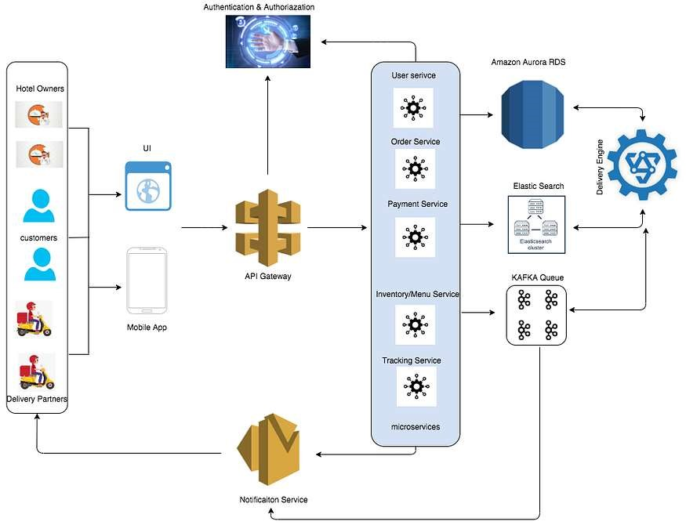

Here’s a high-level architecture for the project:

1. **Data Storage**: Food delivery apps use databases to store data about users, restaurants, orders, and more.
2. **Data Processing**: Food delivery apps can use data to help improve customer satisfaction, build brand image, and increase sales.
3. **Machine Learning**: Food delivery apps use machine learning to improve their algorithms, which can help users get a more personalized experience. For example, Zomato uses machine learning to automate menu digitization, create personalized restaurant listings, and predict food preparation times.
4. **Data Visualization**: The processed data and the results from the predictive models are visualized in real-time using Power BI. Power BI allows you to create interactive dashboards that can provide valuable insights into the data.
5. **Data Access**: The dashboards created in Power BI can be accessed through Power BI Desktop, Power BI Service (online), and Power BI Mobile.

This architecture provides a comprehensive solution for real-time analysis of food delivery apps. However, it’s important to note that the specific architecture may vary depending on the food delivery connection, specific requirements, and budget. It’s also important to ensure that all tools and services comply with relevant data privacy and security regulations.

### CHAPTER 4



### MODELING AND RESULT

#### Manage relationship

The “cuisines” file will be used as the main connector as it contains most key identifier (Restaurant ID, Fact table and Zomato global) which can be uses to relates the 4 data files together. The “country code” file is use to link the client profile geographically with “Zomato global”

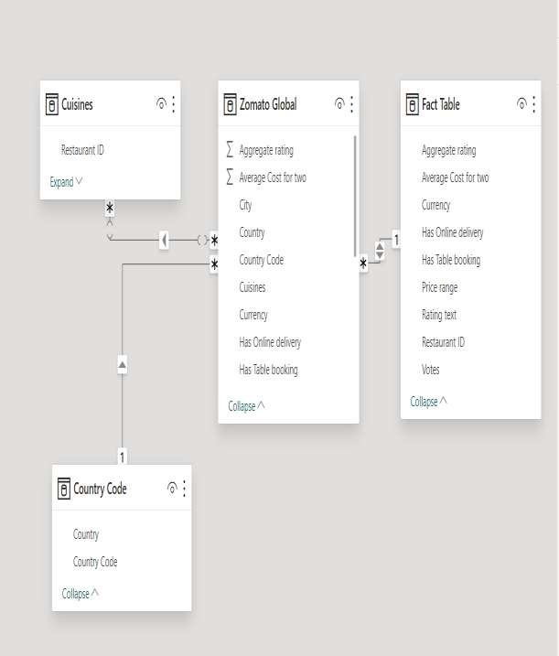

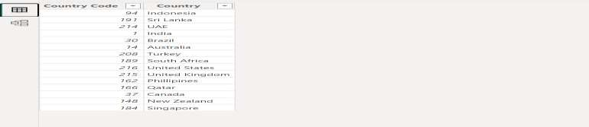

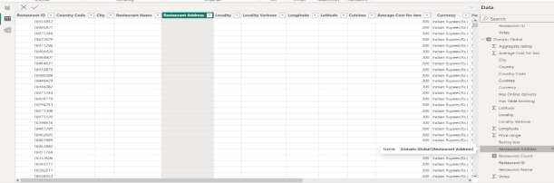

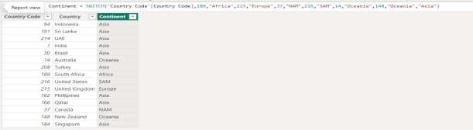

##### Modelling for Gender and Age data

Notice that the Gender and age of the client are missing from the data. These can be formulated from the birth number YYMMDD where at months (the 3rd and 4th digits) greater than 50 means that client is a Female. We can create a column for Gender.

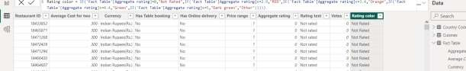

For birthday, we need to reduce the birth month of the female by 50 and then change the date format to DD/MM/YYYY adding 1900 to the year.

For Age, we shall assume it is year 1999 as explain previously and use it to minus from the birth year.

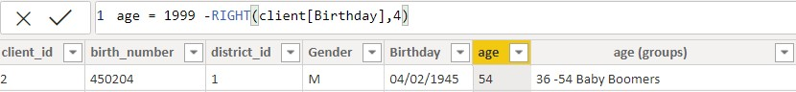

##### Replacing values

Set some fields to English for easy understanding, we replace values to English with the Power Query Editor.

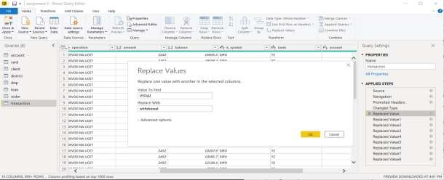

Changing the order of Region name at Power Query

Duplicate the “district /region” then split column using space as delimiter.

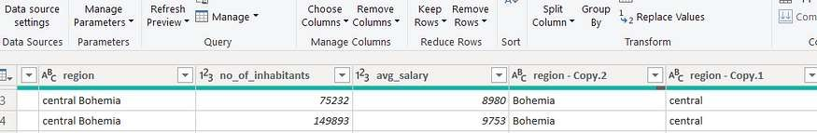

Then merge column by Region and direction. Refer to applied steps for details.

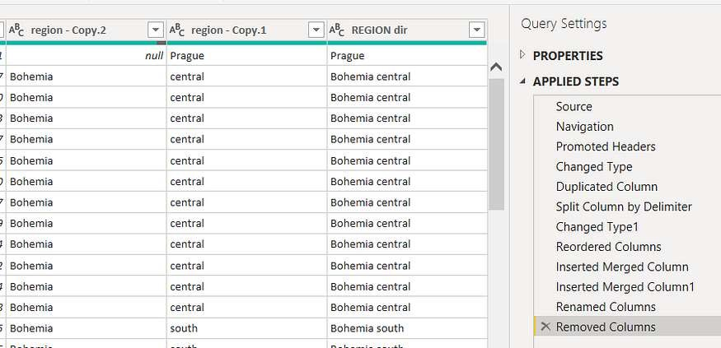

##### Grouping of age by ranges

As the customers’ age ranges from 12 to 88, we shall group them into different generation age range for easier profiling, we will group the ages into 5 groups.

The Gen Y are youths,

Gen X are young working adults, some starting their families Baby Boomer are working adults with families.

The silent Generations some are working and retired, living on pensions.

The greatest Generation, retired elderly living on pensions.

Values of such as “account Id” have also been set as Text.

And District name have been categorized as place to be use for the map to show the sum of the inhabitants in each region.

### Dashboard

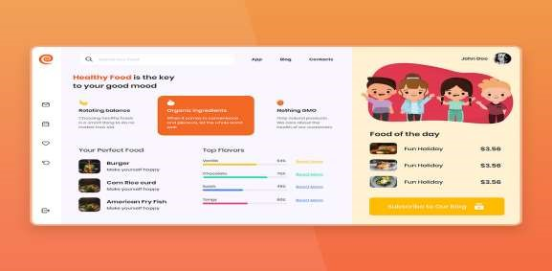

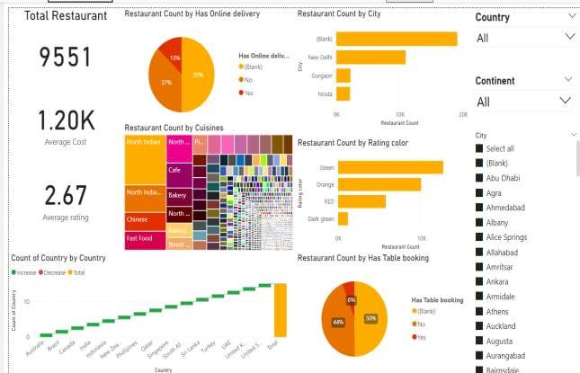

#### CONCLUSION

Nowadays, the traditional way of going to a restaurant and eating has reduced considerably. It's a new age where technology dominates human life. With the software and technological devices, exceptions are reduced and even terminated. Also, people prefer easy, quick and safe access to everything. This project is designed to meet the requirements of a restaurant. The Online Food Ordering System provides a simple way to store details of the customer, food items available and to generate the bill. It is an interface that allows the customer to order the desired food which he/she can relish within a span of forty-five minutes.

The project is designed is such a way that the user can modify the primary information required to manage their profile successfully such as the information about the deliver address and contact number. With this platform we developed, we are hoping to reduce time wasting, avoid misunderstandings, provide easy data flow, customer pleasure, and less hard work. We believe that we have accomplished our goals and satisfied with the code we developed.

#### FUTURE SCOPE

The future scope of this project is vast. With the advent of advanced analytics and machine learning, Power BI can be leveraged to predict future trends based on historical data. Integrating these predictive analytics into the project could enable the bank to anticipate customer needs and proactively offer solutions. Furthermore, Power BI’s capability to integrate with various data sources opens up the possibility of incorporating more diverse datasets for a more holistic view of customers. As data privacy and security become increasingly important, future iterations of this project should focus on implementing robust data governance strategies. This would ensure the secure handling of sensitive customer data while complying with data protection regulations. Additionally, the project could explore the integration of real-time data streams to provide even more timely and relevant insights. This could potentially transform the way banks interact with their customers, leading to improved customer satisfaction and loyalty.

#### REFERENCES

1. <https://cuzegbu.medium.com/ux-case-study-food-delivery-app-design-2a001c78db96>
2. <https://bootcamp.uxdesign.cc/ux-case-study-online-food-delivery-aac10a67d2e>

#### LINK https://github.com/bhuvaneswari233-360-Degree-business-analysis-of-food-delivery-apps-POWERBI